2 or 3 short answer programming problems in Python
• Review homework 1
• Know the definition of time complexity.
DEFINITION:
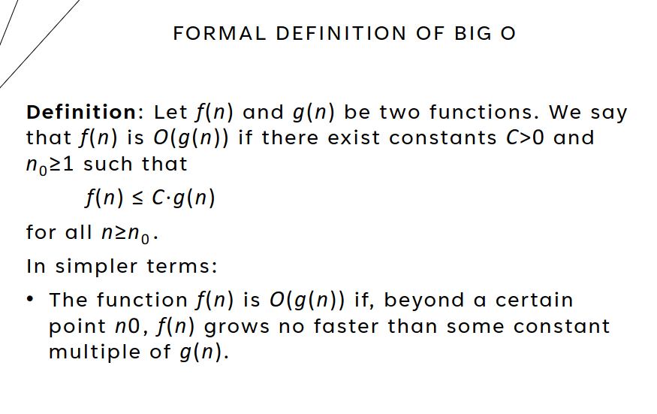
Picture above for Def of Time Complexity
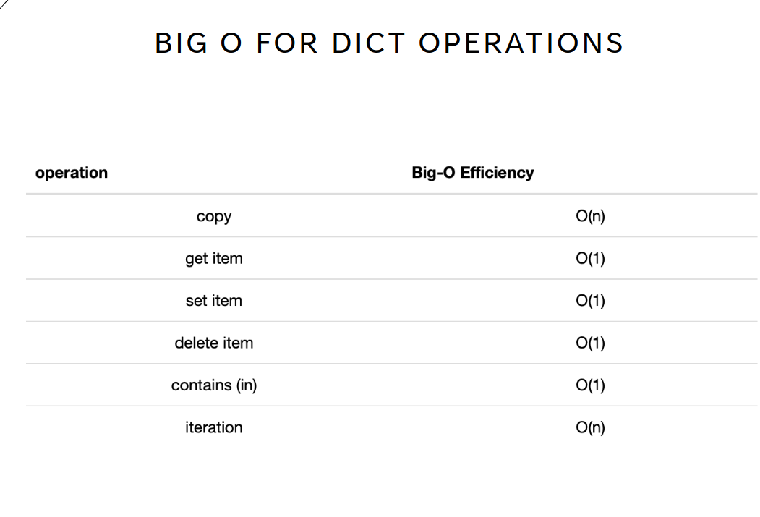
• Know time complexity of list and dict operations. The picture above shows them.
• 2 or 3 problems that involve determining the time
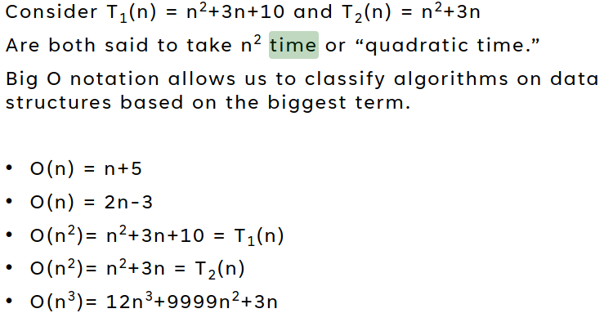
complexity of a block of code. Big O problems, easy reference sheet below

